# 

# Setup New Device

You've received your new computer from IS?  Yay!  Let's get it out of the box and set it up.

**\*\*\*It's important that your new computer is connected to power and the wired network first (either with a network cable or on a dock that is connected to the network)\*\*\***

Once you're connected to power and a wired network, it's ok to power on the device.

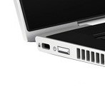      or     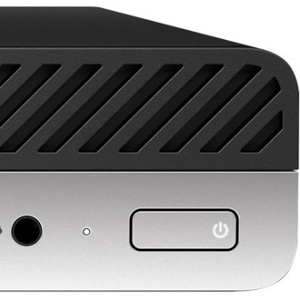

The following screens will ask you a few setup questions.

If you're setting up a laptop, you will see the Cortana screen, Microsoft's chatty assistant.  You can press the **F5** key on a laptop or use the mouse to click the sound icon and mute the sound.

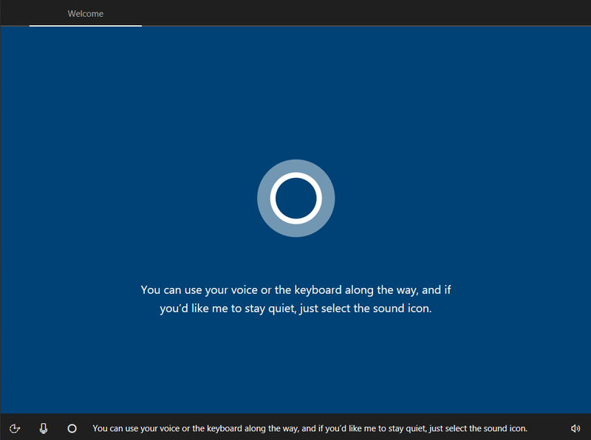

Use the **Touchscreen**on a laptop or the mouse on a PC to set the region to **New Zealand.**

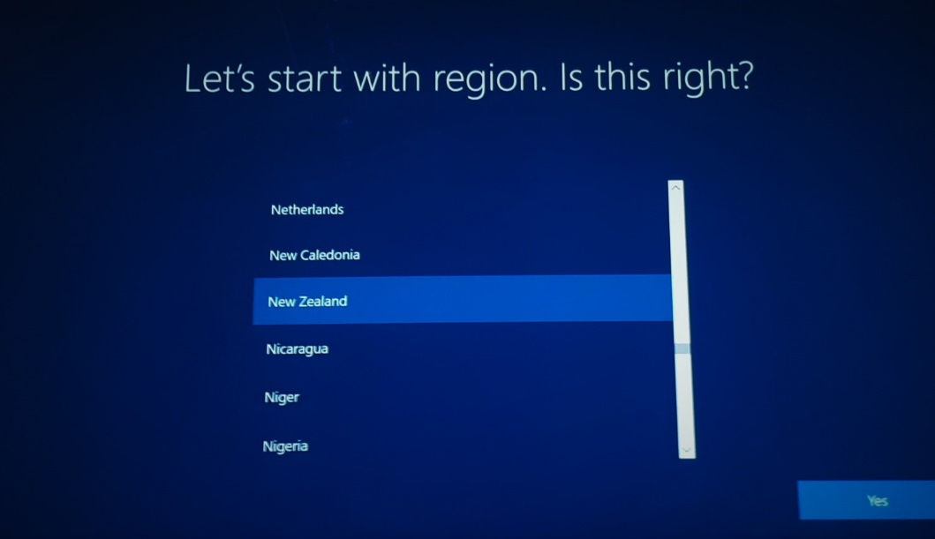

Next, set the keyboard to **United States-International**and press**Yes**

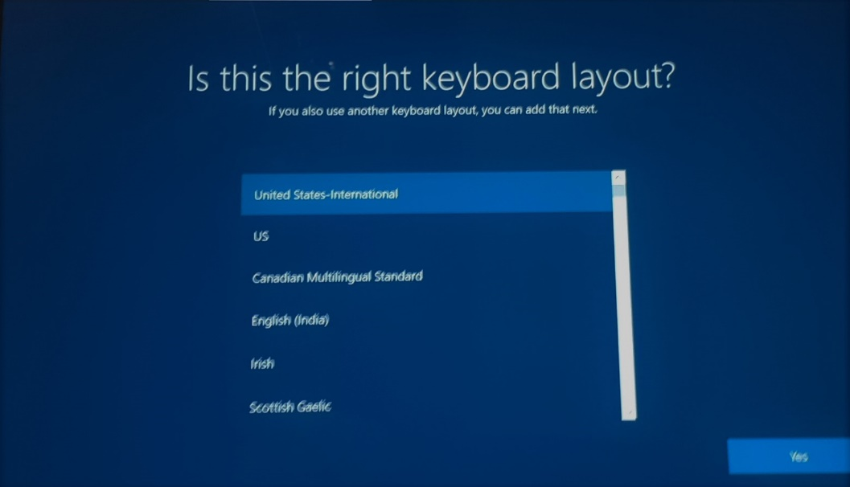

When asked to add a second keyboard layout, select **Skip**

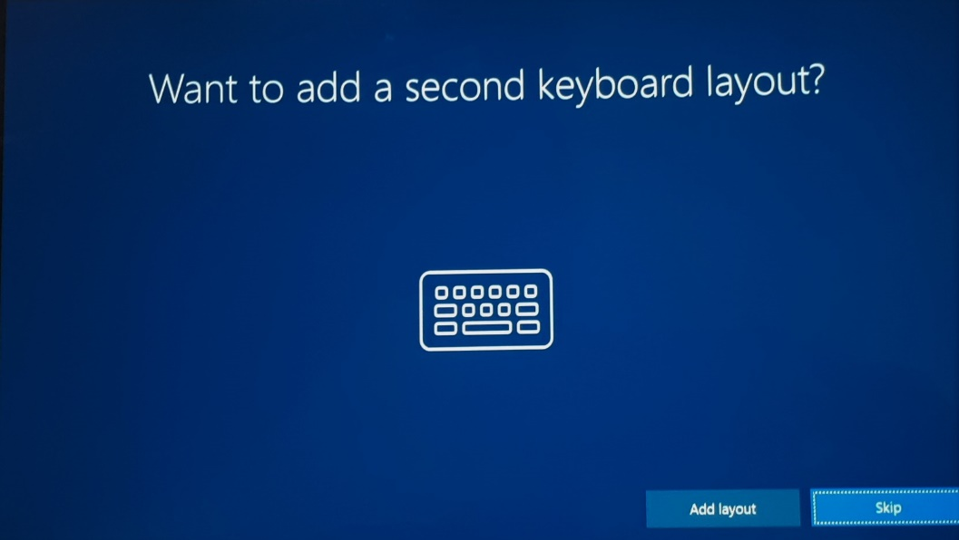

The system will then continue to install software.  It may reboot at this time.

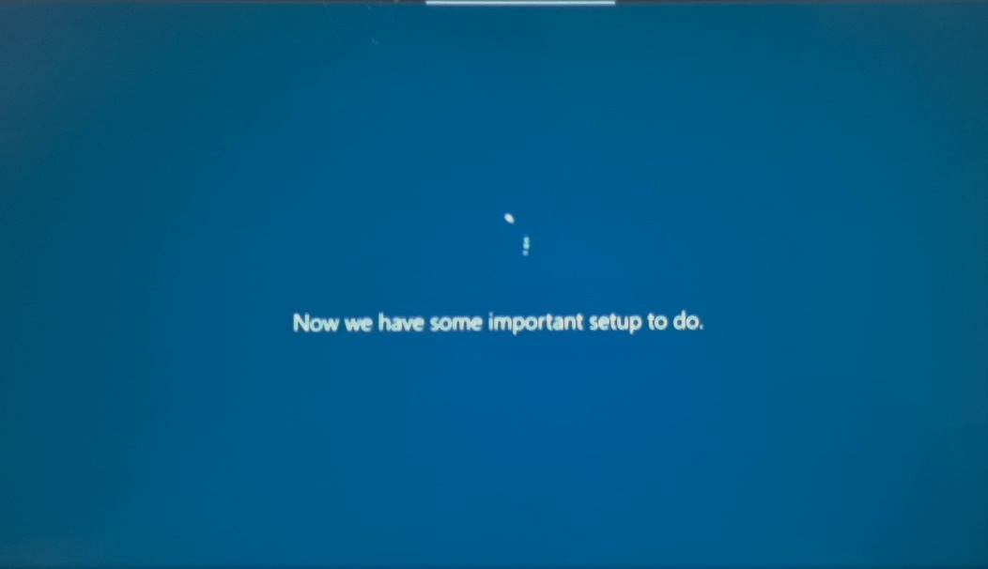

If you get prompted to connect to a network, do **not** select wifi.  Instead, make sure the **wired** network **wisetrust-int.co.nz** is showing and press Next



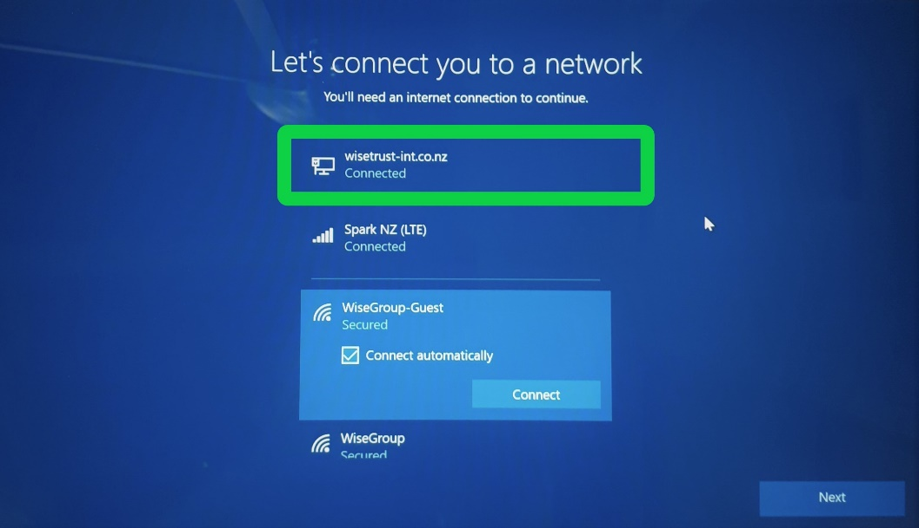

At the Welcome to Wise Group! screen, enter your **email address.**

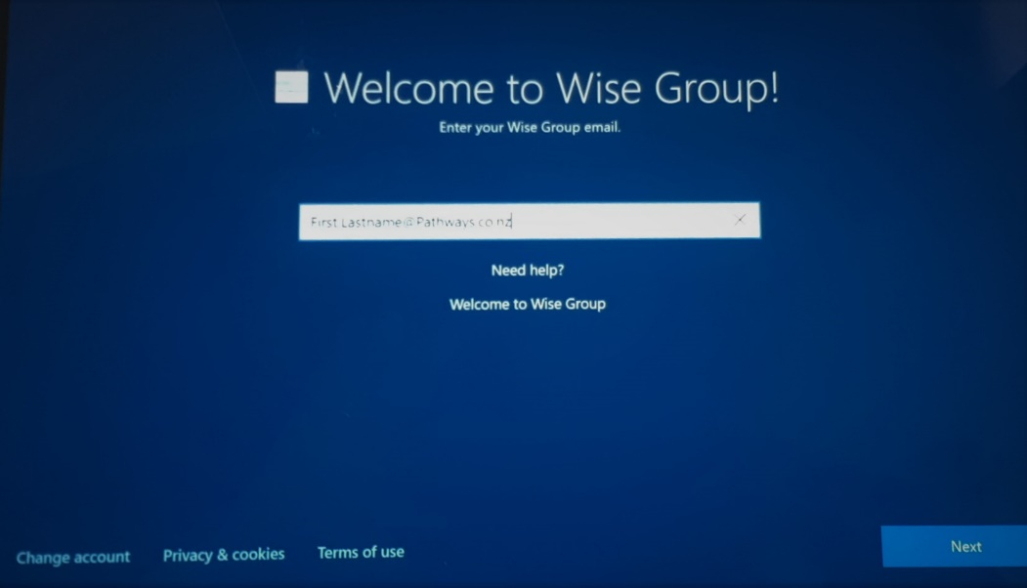

The computer will then continue doing setup in the background. Time to get a cuppa, this could take up to 20 minutes. If you see an **error** here, you can press the “**Try Again**” button.

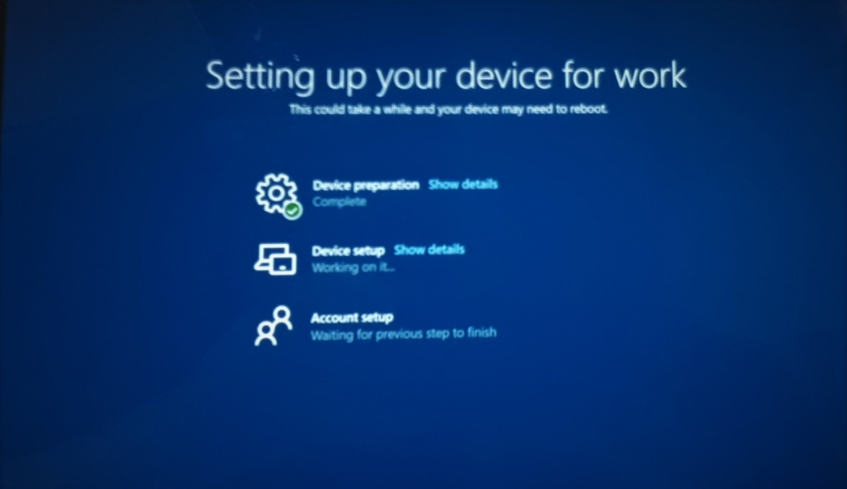

When you see the Microsoft sign in screen, enter your **email address.**

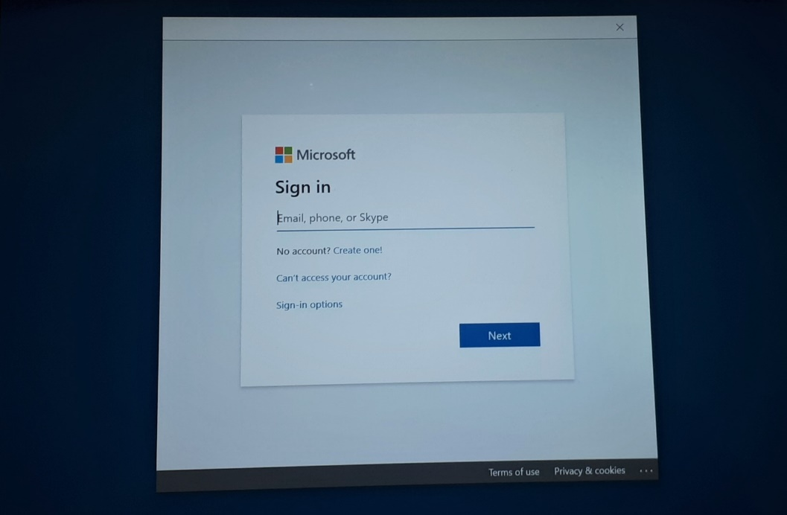

You will then be brought to a Wise Group branded page to enter your **password.**

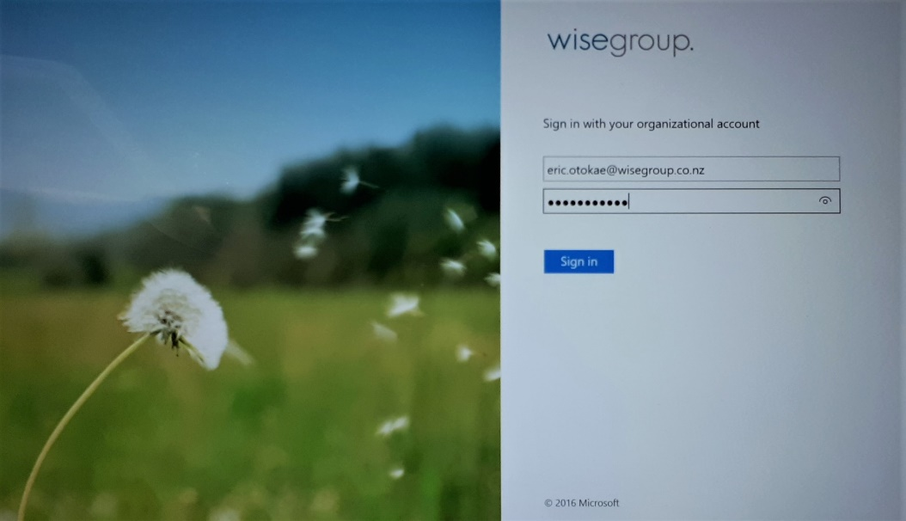

When prompted to “Use this account everywhere on your device,” ensure the **Allow** my organization to manage my device **is** checked, then press **Yes.**

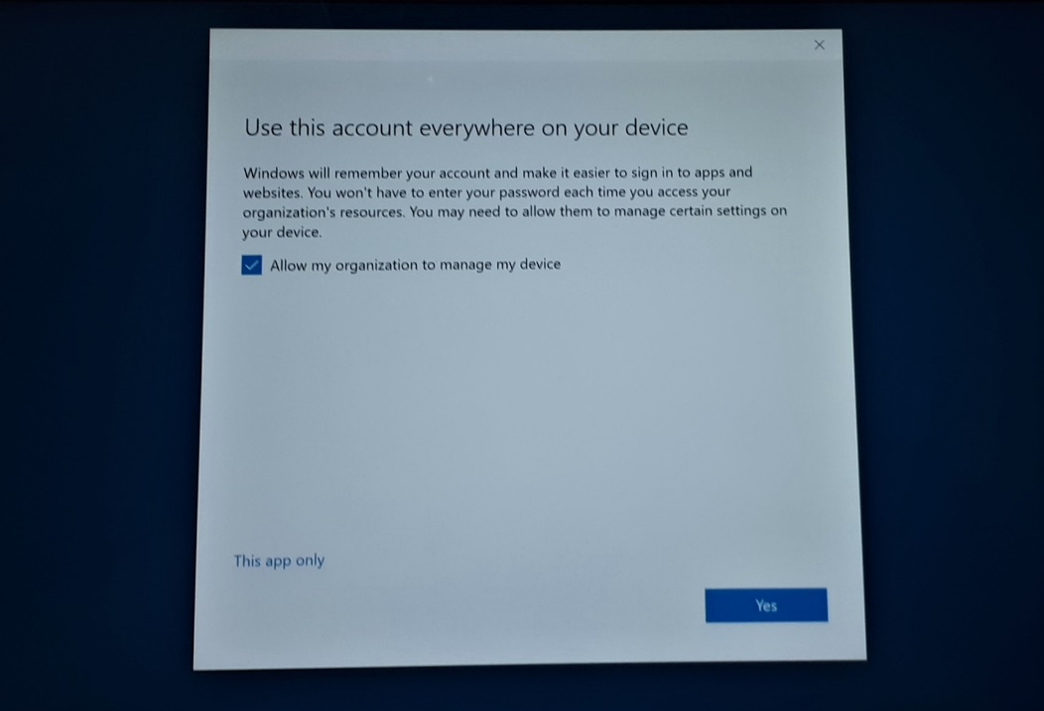

The initial setup will now be complete.  You can then login with your normal username and password to sign into the computer.  The first time you login, the computer will take a few more moments to setup your profile on the machine.

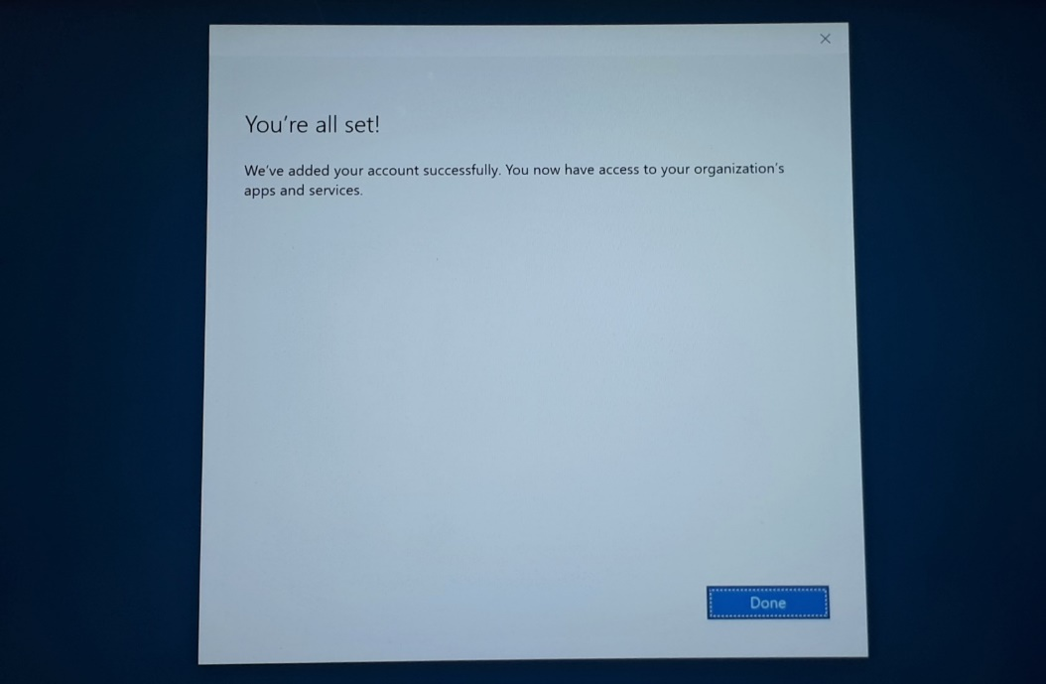

Once you've finished signing into Windows, it's a Good Idea (TM) to **restart** the machine to allow final setup of the machine. There will still be a few things setting up in the background, so give it 10 minutes to settle into its new home, then give it the old IT turn it off and back on again.   Ta-Da!  Enjoy!

